# xpedx.com Next generation

# *Sample Requests Design Document*

**Authors: Sterling Commerce**

**Date Created:** 04/12/10

**Last Updated:** 6/16/2010 10:32 AM

**File Name:** C:\Documents and Settings\bfurman\My Documents\Temp\Methodology v1.1\Project Management\TEMPLATE - DOCUMENT - Use Case Definition.docxpedx Samples Detail Design Doc V1.1.docx

Approval Signatures (Mandatory)

|  |  |  |  |  |
| --- | --- | --- | --- | --- |
| **Title** | **Name** | **Signature** | **Date** | **Comments / Issues / Concerns** |
| **xpedx Owner(s)** | Steve Bugher |  |  |  |
| Cheryl Tullis |  |  |  |
| **Sterling Commerce Owner(s)** | Guy Read |  |  |  |
|  |  |  |  |

**Note**: The sign off indicates approval of all sections of the document.

Document Revision History

This chart tracks the changes introduced by the revisions to the document as the project progresses through the stages of the System Development Life Cycle (SDLC).

| Version | **Date** | **Description (Changes Made)** | **Author(s)** |
| --- | --- | --- | --- |
| 0.1 | 04/12/2010 | Initial Draft | Sterling |
| 1.0 | 04/16/2010 | Ready to deliver | Sterling |
| 1.1 | 06/16/2010 | Updates based on feedback dated 20100614 and subsequent meetings. |  |
|  |  |  |  |

Related or Reference Documents

| Document Name | Description | Owner | Location |
| --- | --- | --- | --- |
| SCI_Xpedx Solution Definition Document v1.5 | Solution Definition document | Sterling Commerce |  |
|  |  |  |  |

TABLE OF CONTENTS

1. Introduction 4

1.1 Document Purpose 4

1.2 Document Audience 4

2 News Articles 5

2.1 Functions & Solution 5

2.1.1 Company News 5

2.1.2 Customer News 5

2.1.3 Structure of a News Article 6

2.2 News Article Screens 6

2.2.1 News Articles List Page (Admin) 6

2.2.2 Create Article Page 6

2.2.3 Edit Article Page 7

2.2.4 News Articles List Page (User) 7

2.2.5 News Article Detail Page 7

2.3 Master System 8

2.4 Implementation Details 8

2.4.1 Entity objects. 8

2.4.2 Actions involved and Functions 8

2.5 Process Flow 8

2.6 Screen Shot 9

2.7 Open Questions 13

2.8 Assumptions 13

3 Glossary of Terms 14

# Introduction

## Document Purpose

This document is the governing functional design document for the Sample Requests functionality. It presents significant decisions and constructs used in developing the functionality. Testing, builds, configuration management are not covered in this document.

The document will also serve the purpose of keeping a list of assumptions that were made during design discussions.

## Document Audience

This document is intended for management and technical staff working on this project, xpedx IT and Business, webMethods, Legacy(MAX and ACCESS), HP, IW, xpedx/IP Network Team. Sterling will use the document during design and configuration for design consideration.

# Sample Requests

## Functions & Solution

Sample Requests are a way for xpedx to request for samples of item(s) that they may want to try out before buying.

A few different ways are used to capture/manage sample requests.

1. ***Paper*** – The sample requests are managed by a 3rd party tool called the Sample Application Manager (SAM). While the SAM tool tracks sample requests, our customers can request paper samples through the Web Channel. The Paper samples should be e-mailed to the xpedx Sampling Centers across the country, depending on which division the customer is tied to.
2. ***Facility Supplies, etc.*** – The sample requests are simple forms that the customer fills out on the web and an email is sent out to the division’s CSR & Sales Rep.

## Sample Requests

For Paper type samples, there are Sample Centers around the country and they have divisions associated to them. Based on the division to which a customer is associated to, the sample request is routed to the appropriate Sample Center. This routing logic will not be implemented in Sterling for BR1. This will be implemented in BR1. This information can be derived from the Division & Customer Profile. You have to send the form somewhere.

For BR1 – Sterling will implement a simple form based sample request for all types of samples.

There are two launch points for requesting samples.

1. From an item detail page – link called “request sample”
2. From the home page via the ‘Services’ tab

There is no flag today to identify the items that may be sampled by a customer. Hence all items will have the “request sample” link. However, this does not guarantee that a sample will be sent to the customer.

For the majority of the cases, samples are requested one item at a time. Hence, it would be useful to have the item/customer information pre-populated in the Sample Request form when the “request sample” link is clicked from within an item.

Once a sample request is submitted, Sterling converts it to an email and sends the email to the recipients specified in the Customer Profile.

## Sample Request Business Rules/Routing

Customer Profile flag – Service Optimization Code – categorizes customers into

K – Key

P – Preferred

Q – Quality

V – Value

By default, the ability to request samples (i.e. the “Request Sample” link) will be turned off for “Value” and “Quality” customers.

In addition to the above business rule, two new fields will be added to the customer profile -

1. Sample form accessible from Item Detail – Yes or No. Defaults to Yes for all customers
2. Sample form target email ids – A list of email addresses that will receive the sample form when it is submitted. Initially it defaults to the Sales Representative associated with the Customer.

## Structure of a Sample Request

Sample requests have the following fields

1. Header Information
   1. Requested Delivery Date
   2. Customer Job Title
   3. Notes
2. Customer Information
   1. Account Number
   2. Customer Name
   3. Customer Contact Name
   4. Contact Phone Number
   5. Shipping Address 1/2/3
   6. City/Sate/Zip
3. Company/Division Information
   1. Division Number/Name associated to customer account
   2. Sales Representative 1 – tied to the customer account.
4. Item Information – Multiple Lines
   1. Manufacturer
   2. Manufacturer Part Number
   3. Item description
   4. Quantity (?)
   5. Unit of Measure (?)

## Sample Request Screens

The list of all pages related to Sample Requests

1. New Sample Request Page
2. New Sample Request Lightbox

## New Sample Request Page

This page displays the customer/company info prepopulated. It has a fixed number of lines (10) to enter in the item information fields that are listed in 2.1.2. So a customer can request a maximum of 10 item samples per form.

Note: If the user navigates away from this page, the information that the user entered/selected (e.g. item info) will be lost. Sterling will not store any of the fields on a sample request. This will be conveyed clearly to the user via messaging based on the UI design.

Pre-populated fields –

1. Customer Information
2. Company/Division Information

Customer entered fields

1. Header Information
2. Item Information

Actions – The following actions are permitted on this page

1. Edit the Customer Information
2. Edit the Company/Division Information
3. Edit the Header Information
4. Edit Item Information
5. Submit the sample request
6. Cancel the sample request

## New Sample Request Lightbox

This light box is used to request a sample for a single item. A user arrives on this light box by clicking the “request sample” link from an item detail page. Once the link is clicked, the user is presented with a form that has many of the elements prepopulated. The user then has the opportunity to edit some of the details and submit the request.

Pre-populated fields –

1. Customer Information
2. Company/Division Information

Customer entered fields

1. Header Information

Actions – The following actions are permitted on this page

1. Edit the Customer Information
2. Edit the Company/Division Information
3. Edit the Header Information
4. Submit the sample request
5. Cancel the sample request

## Master System

N/A – No samples related information is stored in Sterling.

## Implementation Details

## Entity objects.

## Actions involved and Functions

## Process Flow

## Screen Shot

The screen shots pasted here are still in review and not final. This is just an illustration of how it looks today.

***Request Sample Page***

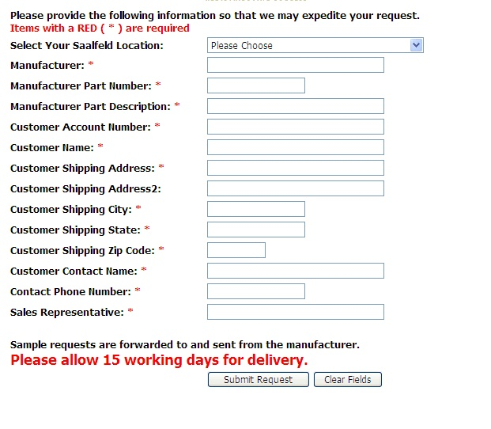

## Open Questions

1. Per the business requirements for BR1 we were going to manage all samples in SAM and Sterling would provide a link to the application. This has changed – I would like to confirm the change in requirements. [Steve B. 20100426 - BR 1 will include a web form for the type of Sample Request. Paper Sample form example attached below]
2. Which email address is the sample request email sent to? [Cheryl T. - ? Sample form target email IDs, see 1.1.2.] [Prashant – 20100616 – Didn’t find anything in the feedback relating to the email]

CK – Paper samples need to be sent to the Sampling Centers (driven based on customer servicing division), Pkg/FS products need to be sent to the Customer’s CSR & Sales Rep.

1. UI templates for
   * Sample Create Request
   * Multiple lines in a sample request form
   * Email template where the samples request is submitted to.
2. Can only customers request samples? [ Steve B – 20100426 – Yes.]
3. On the Saalfeld form there are no notes, item qty or item uom. Do we need these? CK – Saalfeld, xpedx, and all other brands will now use the same sample form.
4. Do we need to support Shipping Method ? [Steve B. – 20100426 - not for Saalfed web form ,but for Print web form, we do] CK – Saalfeld, xpedx, and all other brands will now use the same sample form.
5. [Steve B. – 20100426 - Are we saying a user can only add one item to a Sample request from the Catalog? I.e. Once they add the item, they must either manually add items or submit the Sample Request] [ Prashant – 20100616 – Yes. Based on meeting 6/14, the single item request will be handled via the lightbox while multiple items will be handled through the samples page. This goes back to our discussion of not having to build a cart like functionality just for samples]
6. There was going to be just one web form - Not storefront or brand specific. So the Saalfeld form will have these fields, but they will be ignored by the person receiving the request, right ? [George/Steve 20100615 - Same set of fields not different by segment or brand]

## Assumptions

1. Tracking of sample requests is out of scope for BR1
2. Approval workflows for samples is out of scope for BR1
3. Long term management and tracking of samples is out of scope for BR1
4. xpedx will provide the final screenshots for the pages listed in the screen shots section. Currently we’re using the existing dotcom pages as placeholders to capture the key data elements.
5. Each sample request is a simple form. If a user navigates away from the form, the data entered on that form is lost; i.e., it doesn’t function like a cart where you can go back and keep adding items to the same cart. We need a message if the user tries to leave the page, that none of their sample information will be saved. If they’d like it saved, they should complete the form and submit it before leaving the page.

# Glossary of Terms

|  |  |  |
| --- | --- | --- |
| S. No. | Term | Definition |
| 1. | Content Server | A server that hosts all the collateral such as images, specification sheets, etc. |
| 2. | BR1 | Business Release 1 |
| 3. | IW | Industrial Wisdom – UI firm engaged on the project. |
|  |  |  |